COMPUTER SCIENCE
PROJECT FILE
ON
SCHOOL MANAGEMENT SYSTEM


PROJECT PREPARED BY:
PURVANGIPATEL
Roll No. 11620210
XII B
Session: 2021-2022
Bharatiya Vidya Bhavan’s V. M Public School

TABLE OF CONTENTS

- Synopsis

- Certificate

- Acknowledgement

- Modules

- Coding

- Outputs

- Bibliography

SYNOPSIS

Topic: SCHOOL MANAGEMENT SYSTEM

Features: it avoids manual paper work and automates many school administrative activities.it also has a facility of adding ,displaying and updating students details and teachers also.

Hardware/Software Requirements:
- operating system: windows 10
- mysql
- spyder (python)

Future Scope: it avoids manual paper work it also avoids unnecessary wastage of time. In future the project can be enhanced by adding many more features other than the present ones. Like we can also record marks and generate report card and also we can add a searching feature .we can also keep a record of fees.

Limitations: This project is limited to update record at once as in this we can only update records manually and not at once.

Made By:
Accepted/Rejected
Purvangi p patel

Certificate

This is to certify that Purvangi Patel of Std. XII
B, Bharatiya Vidya Bhavan’s V.M Public School , Vadodara has successfully completed project entitled School management system in computer practicals for the AISSCE as prescribed by CBSE in the year 2021-2022.

Date :

Roll No. :11620210

Signature of Internal Signature of External
Examiner Examiner

__________________ __________________

Acknowledgement

I would like to express a deep sense of thanks & gratitude to my computer science teacher MRS SONAL SHARMA mam for guiding me immensely through the course of the project.
My sincere thanks to our Principal R K SINGHAL sir for his co-ordination in extending every possible support for the completion of the project.

MODULES USED

import mysql.connector as p

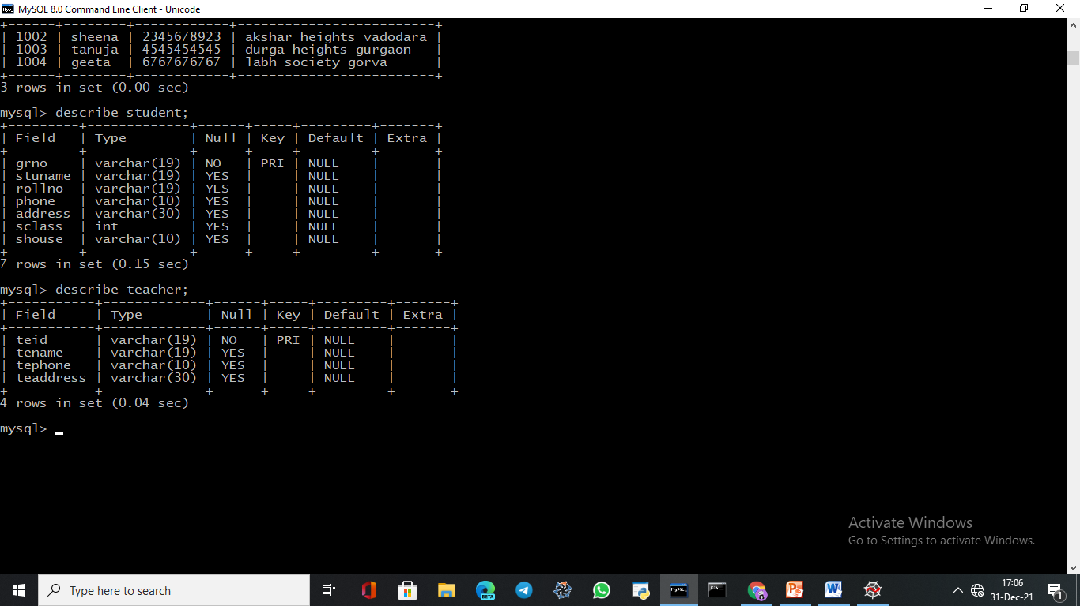
DATABASE SCHOOL
It contains student table and teacher table where we can add delete update and display records of students as well as teachers

CODING

import mysql.connector as p
dat=p.connect(host="localhost",user="root",passwd="purva",database="school")
#for student
#to add new student
def addnewStudent():
k=int(input("how many records of student you want to add??????"))
for i in range(k):
grno=int(input("Enter Grno :"))
sname=input("Enter Name:")
rno=int(input("Enter Rollno:"))
pho=int(input("Enter Phone Number:"))
add=input("Enter Address:")
sclass=int(input("Enter Class:"))
shouse=input("Enter House:")
c1=dat.cursor()
query="insert into Student (Grno,StuName,Rollno,Phone,Address,SClass,SHouse)values('{}','{}','{}','{}','{}','{}','{}')".format(grno,sname,rno,pho,add,sclass,shouse)
c1.execute(query)
dat.commit()
print("Record Added Successfully")
h=input("do you want to enter more records???(y/n)")
if h=='n':
break
c1.close()

#to display student record
def displayStudent():
c1=dat.cursor()
c1.execute("select * from Student")
data=c1.fetchall()
print("-------------------------------------------------------------------------------------------------------")
print("Grno\tSName\t\tRno\t\tPhone\t\t\tAddress\t\tCls\t\tHouse")
print("--------------------------------------------------------------------------------------------------------")
for row in data:
print(row[0],"\t\t",row[1],"\t\t",row[2],"\t\t",row[3],"\t\t",row[4],"\t\t",row[5],"\t\t",row[6])
print("------------------------------------------------------------------------------------------------------")
c1.close()

#to update the student record

def updateStudent():
c1=dat.cursor()
if dat:
Grno=input("Enter Grno.: ")
query="select * from Student where Grno='{}'".format(Grno)
c1.execute(query)
data=c1.fetchall()
if data:
print ("*ENTER $ FOR UPDATING ROLLNO*")
print ("*ENTER # FOR UPDATING PHONE*")
print ("*ENTER @ FOR UPDATING ADDRESS*")
print ("*ENTER ^ FOR UPDATING HOUSE*")
print ("*ENTER & FOR UPDATING CLASS*")
symbol=input("Please Enter Your Choice : ")

if symbol=='$':
rollno=input("Enter rollno of the student:")
query="update Student set Rollno='{}' where Grno='{}'".format(rollno,Grno)
c1.execute(query)
dat.commit()
print("Record Updated")

elif symbol=='#':
phone=input("Enter phone no :")
query="update Student set Phone='{}' where Grno='{}'".format(phone,Grno)

c1.execute(query)
dat.commit()
print("Record Updated")
elif symbol=='@':
address=input("Enter address of the student:")
query="update Student set Address='{}' where Grno='{}'".format(address,Grno)

c1.execute(query)
dat.commit()
print("Record Updated")
elif symbol=='^':
house=input("Enter house of the student:")
query="update Student set SHouse='{}' where Grno='{}'".format(house,Grno)

c1.execute(query)
dat.commit()
print("Record Updated")

elif symbol=='&':
clas=int(input("Enter class of the student:"))
query="update Student SET SClass='{}' where Grno='{}'".format(clas,Grno)

c1.execute(query)
dat.commit()
print("Record Updated")
else:
print("Please enter Correct symbol !!!")
else:
print("Wrong Grno Is Entered…Try Again !!!")

#to delete the student record

def deleteStudent():
grno=input("Enter Grno of the student:")
c1=dat.cursor()
query="delete from Student where Grno='{}'".format(grno)
c1.execute(query)
dat.commit()
print("Record is Deleted sucessfully......")
c1.close()
dat.close()
#for teacher
#to add new teacher record

def addnewTeacher():
j=int(input("how many records of teacher you want to add?????"))
for i in range(j):
tid=int(input("Enter teacher id :"))
tname=input("Enter Name:")
tpho=int(input("Enter Phone Number:"))
tadd=input("Enter Address:")
c1=dat.cursor()
query="insert into Teacher(Teid,TeName,TePhone,TeAddress) values ('{}','{}','{}','{}')".format(tid,tname,tpho,tadd)
c1.execute(query)
dat.commit()
print("Record Added.....")
f=input("do you want to enter more records???(y/n)")
if f=='n':
break
c1.close()
# to display teacher record
def displayTeacher():
c1=dat.cursor()
c1.execute("select * from Teacher")
data=c1.fetchall()
print("----------------------------------------------------------------------")
print("Teacherid\tTeacherName\t\tPhone\t\tAddress ")
print("-----------------------------------------------------------------------")

for row in data:
print(row[0],"\t","\t",row[1],"\t",row[2],"\t",row[3])
print("------------------------------------------------------------------------")
c1.close()
#to update teacher record
def updateTeacher():
c1=dat.cursor()
if dat:
tid=input("Enter Teacher id: ")
query="select * from Teacher where Teid='{}'".format(tid)
c1.execute(query)
data=c1.fetchall()
if data:
print ("ENTER * FOR TEACHER NAME")
print ("ENTER @ FOR TEACHER PHONE")
print ("ENTER % FOR TEACHER ADDRESS")

sym=input("Please Enter Your Choice : ")
if sym=='*':
name=input("Enter name of the teacher:")
query="update Teacher set TeName='{}' where Teid='{}'".format(name,tid)
c1.execute(query)
dat.commit()
print("Record Updated......")
elif sym=='@':
phone=input("Enter phone no :")
query="update Teacher set TePhone='{}' WHERE Teid='{}'".format(phone,tid)
c1.execute(query)
dat.commit()
print("Record Updated sucessfully......")
elif sym=='%':
address=input("Enter address of the teacher:")
query="update Teacher set TeAddress='{}' where Teid='{}'".format(address,tid)
c1.execute(query)
dat.commit()
print("Record Updated sucessfully.....")
else:
print("Please Enter Correct symbol !!!")
else:
print("incorrect id Is Entered !!!")

#to delete teacher record
def deleteTeacher():
tid=input("Enter Teacher id :")
c1=dat.cursor()
query="delete from Teacher where Teid='{}'".format(tid)
c1.execute(query)
dat.commit()
print("Record Deleted")
c1.close()
dat.close()

#MAIN

print("\n...........SCHOOL MANAGEMENT SYSTEM .......")
print("\n ...............MADE BY : PURVANGI PATEL...\n")

for i in range(1):
print("---------------------------------------------")
print(" what task you want to perform????? \n")
print(" ^^^^^^^^^^^^^^^^^^^^^^^^^^^^^^^^^^^^^^^^^^^^")
print(" Enter 1 :: Add New Student ")
print(" Enter 2 :: Display Student Data ")
print(" Enter 3 ::Update Student Data ")
print(" Enter 4 :: Add New Teacher record ")
print(" Enter 5 :: Display Teacher Data ")
print(" Enter 6 :: Update Teacher Data ")
print(" Enter 7 :: Delete a Student Record ")
print(" Enter 8 :: Delete a Teacher Record ")
print(" Enter 9 :: way out!!!!")
print(" ^^^^^^^^^^^^^^^^^^^^^^^^^^^^^^^^^^^^^^^^^^^^")
print("---------------------------------------------")
yr_choice=int(input(" Please Enter Your Choice from above : "))
if yr_choice==1:
print("please enter the following details : ")
addnewStudent()
elif yr_choice==2:
print("please enter the following details : ")
displayStudent()
elif yr_choice==3:
print("please enter the following details : ")
updateStudent()
elif yr_choice==4:
print("please enter the following details : ")
addnewTeacher()
elif yr_choice==5:
print("please enter the following details : ")
displayTeacher()
elif yr_choice==6:
print("please enter the following details : ")
updateTeacher()
elif yr_choice==7:
print("please enter the following details : ")
deleteStudent()
elif yr_choice==8:
print("please enter the following details : ")
deleteTeacher()
elif yr_choice==9:
print("Thank you ....for using school mangement system...")
break
else:
print(".....your choice does not exist ....sorry ")

dat.close()

OUTPUTS

- ON CLICKING THE RUN BUTTON 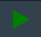

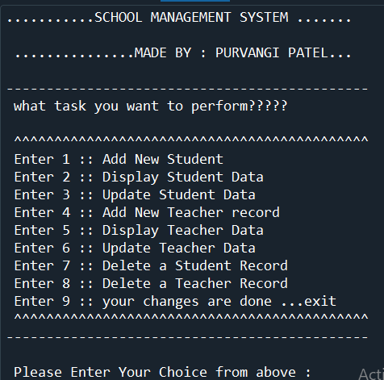

NNNNNN

- TO ADD RECORDS OF STUDENTS

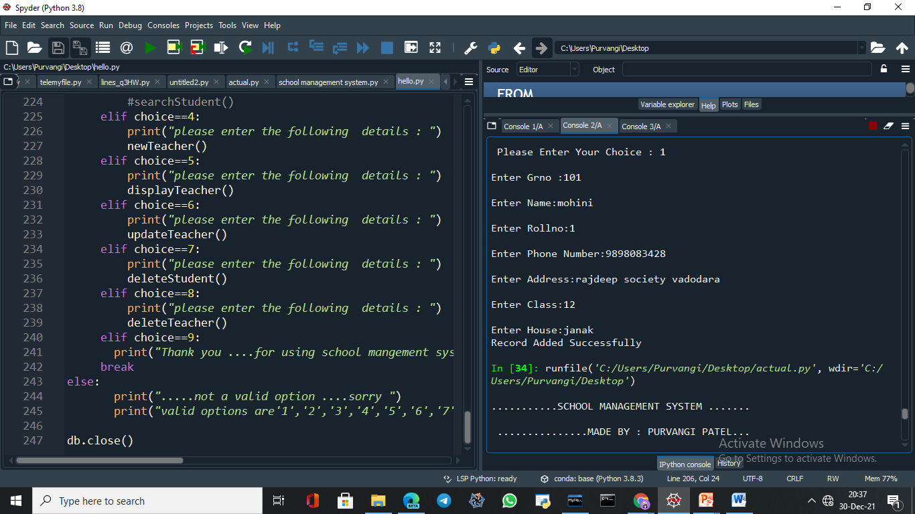
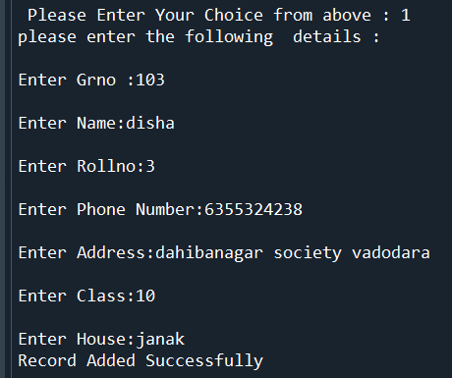

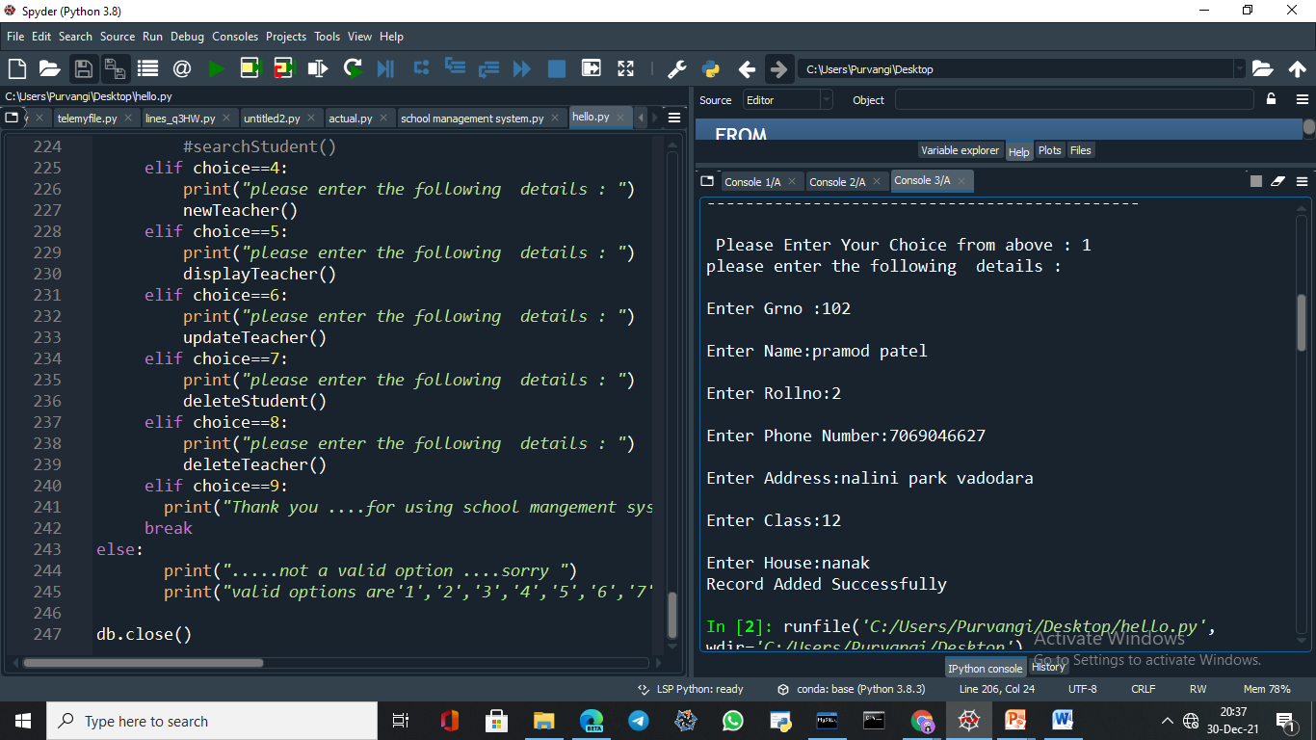
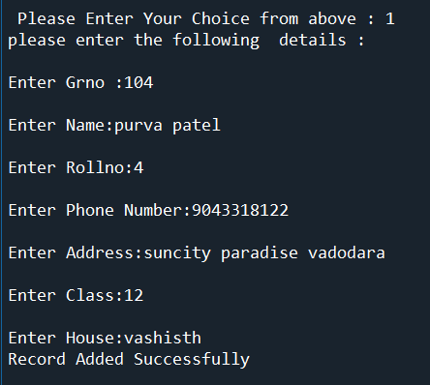

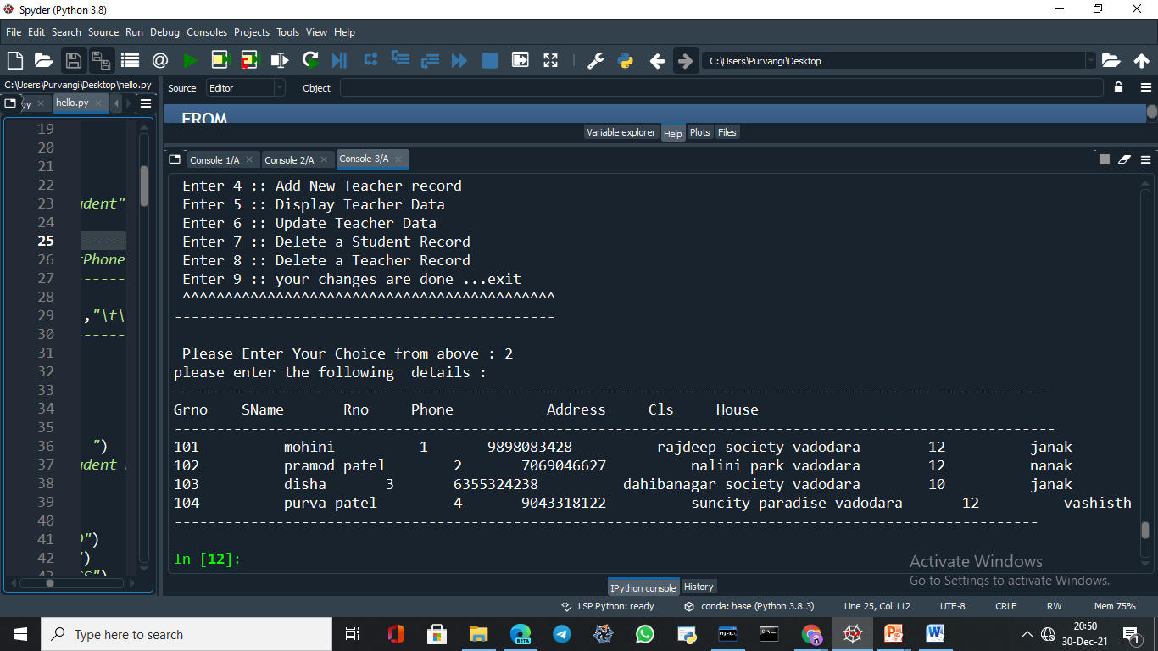
- TO DISPLAY THE RECORDS OF STUDENTS ADDED

- TO UPDATE THE STUDENT RECORD
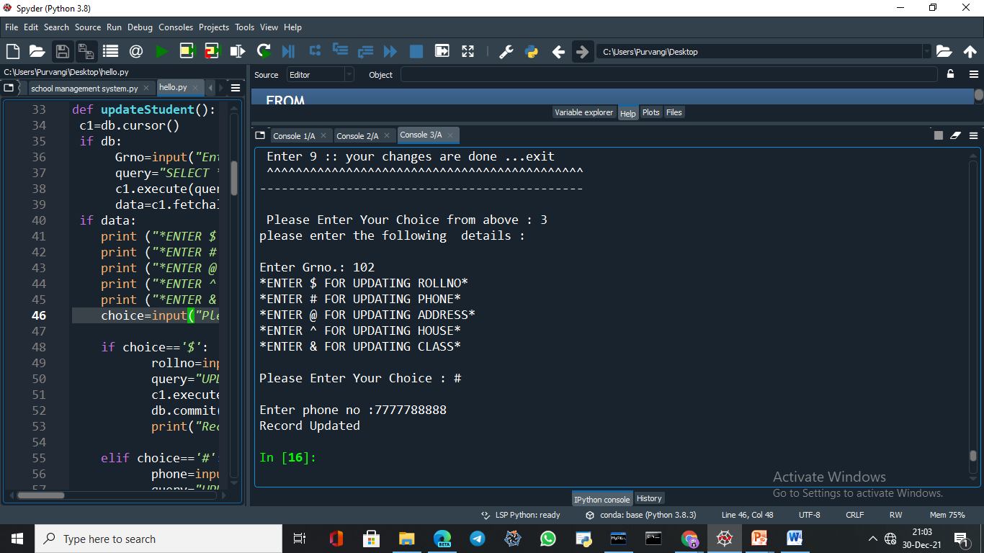

HERE THE STUDENT WHICH HAS GR NO 102 HAS NOW THE PHONE NO
UPDATED ….SIMILARLY CAN BE DONE FR OTHER STUDENTS ALSO.
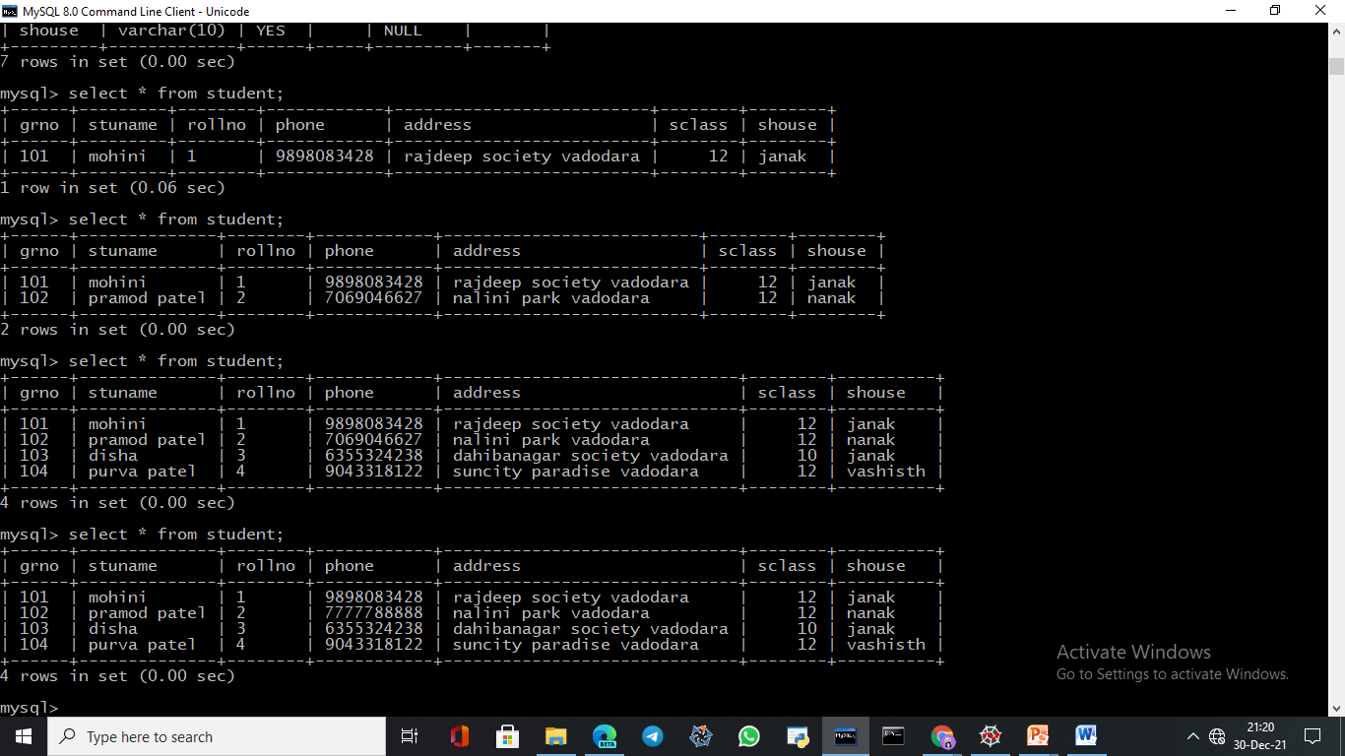
YOU WILL SEE THE SAME CHANGES IN MYSQL TOO ..SEE THE BELOW IMAGE.

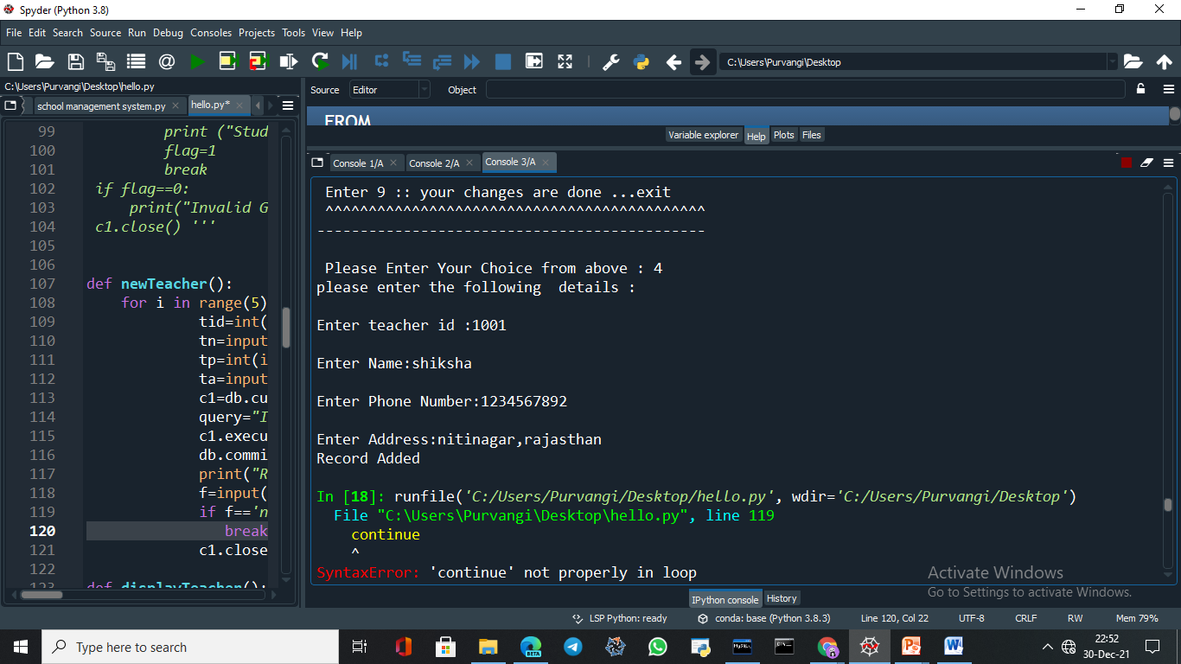
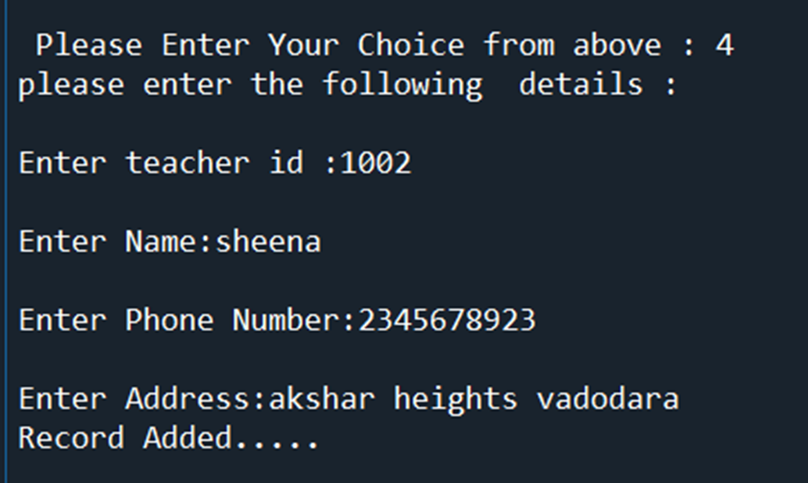
- TO ADD RECORDS OF TEACHERS IN SCHOOL
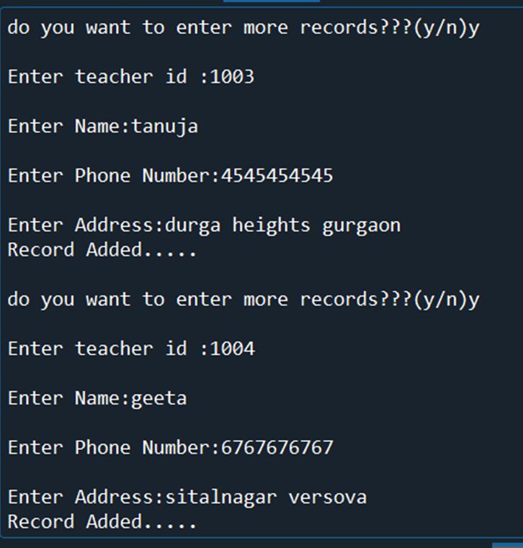

ONNON
- TO DISPLAY RECORDS OF TEACHERS ADDED
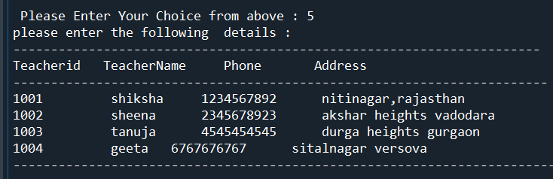
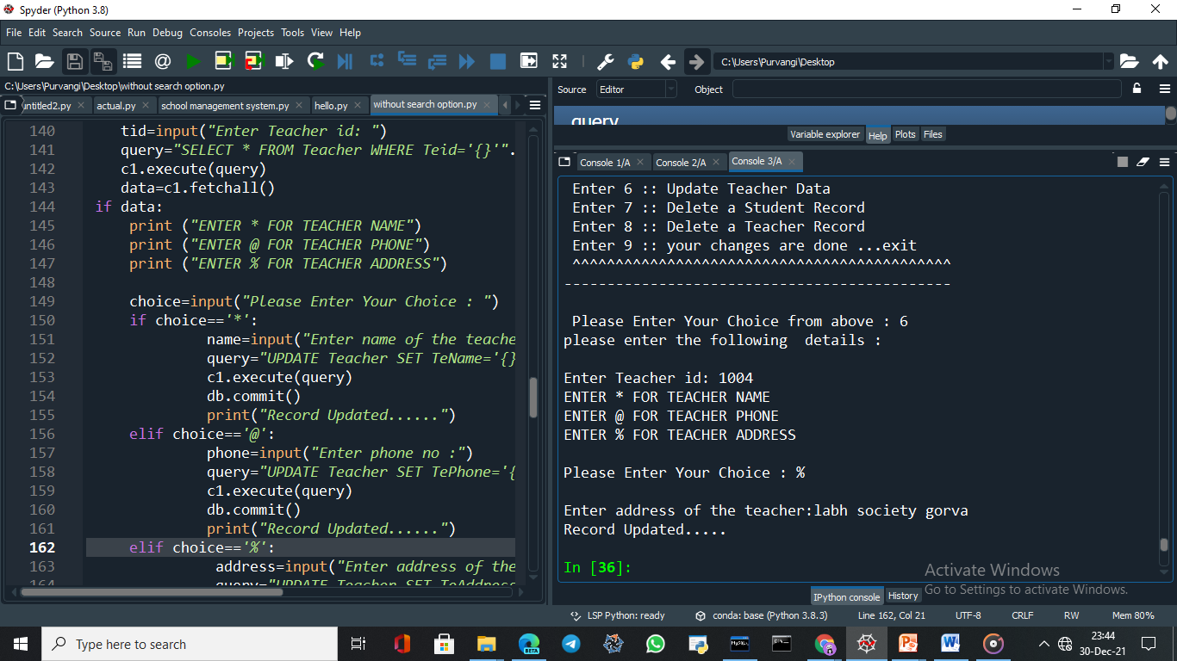
- TO UPDATE THE TEACHER RECORD

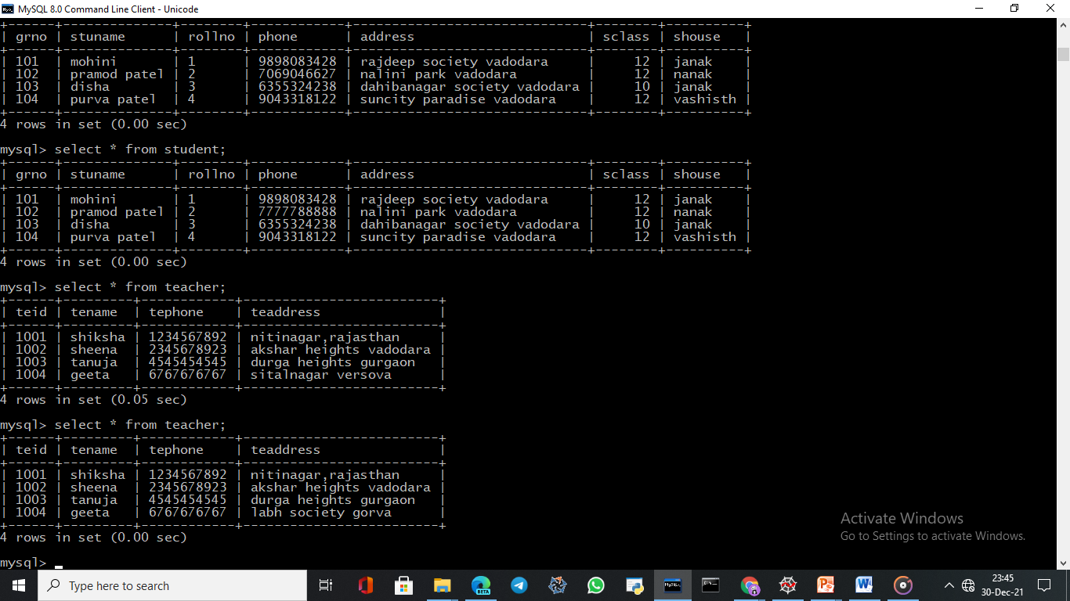
YOU WILL SEE THE SAME CHANGES IN MYSQL SEE BELOW
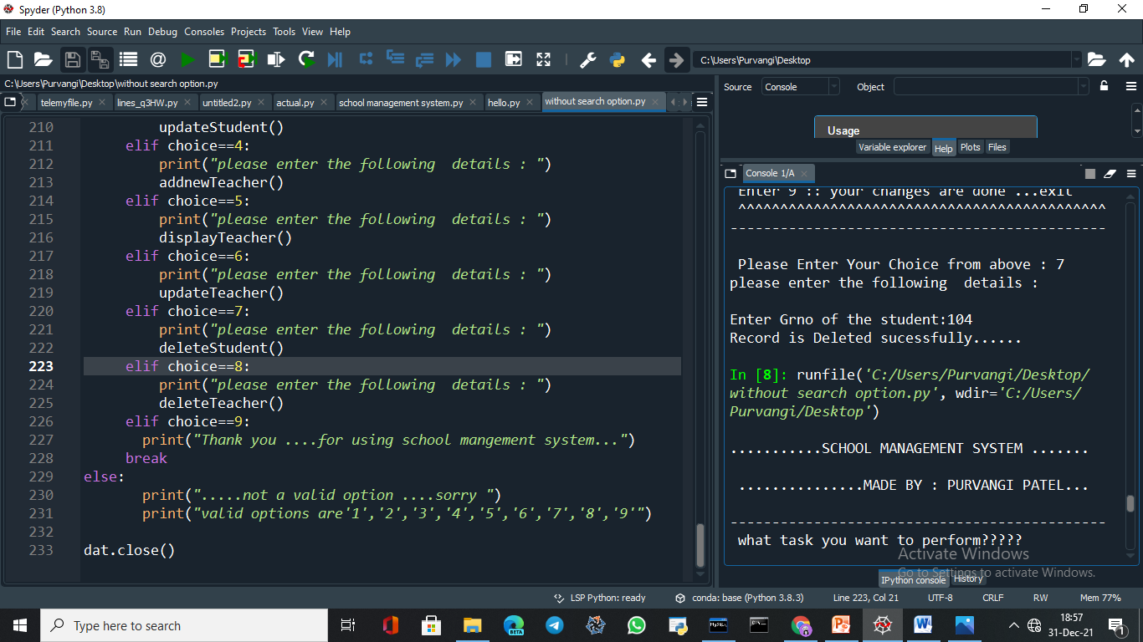
- TO DELETE STUDENT RECORD

- TO DELETE TEACHER RECORD
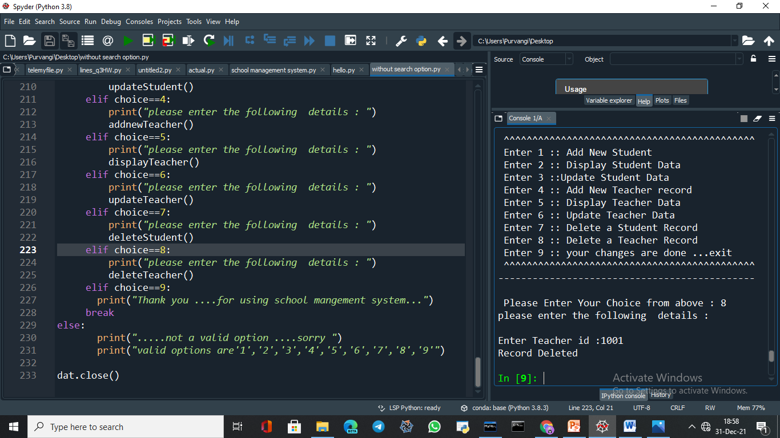 NOW YOU CAN SEE BELOW CHANGES ARE DONE…
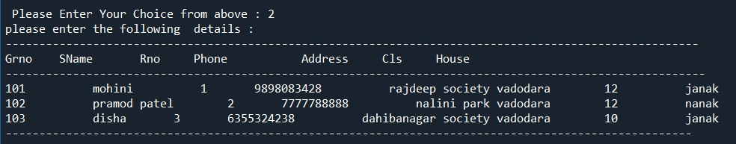
DELETED RECORD 104 FROM STUDENT TABLE

DELETED RECORD 1001 FROM TEACHER TABLE
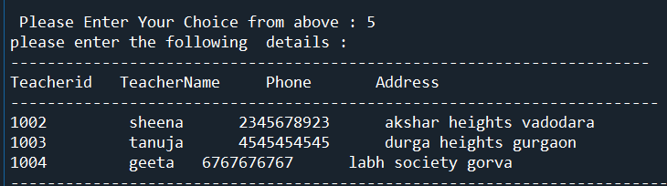
- SIMILAR CHANGES CAN BE SEEN IN MYSQL ALSO SEE BELOW..

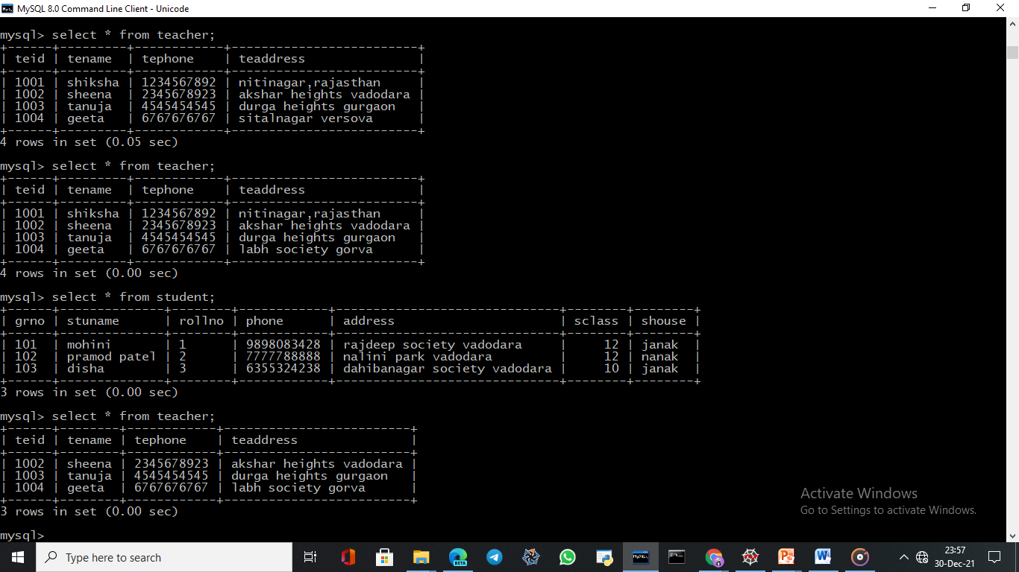
YOU CAN SEE THE RESULT DETAILS OF STUDENT WITH GR NO 104 IS DELETED .

YOU CAN ALSO CHECK THAT NOW RECORD OF TEACHER WITH ID 1001 HAS BEEN DELETED BY JUST ENTERING THE NUMBER 5.

BIBLIOGRAPHY

COMPUTER SCIENCE WITH PYTHON BY :– SUMITA ARORA



